**Design Thinking**

Intersecting Perpendicular Roads

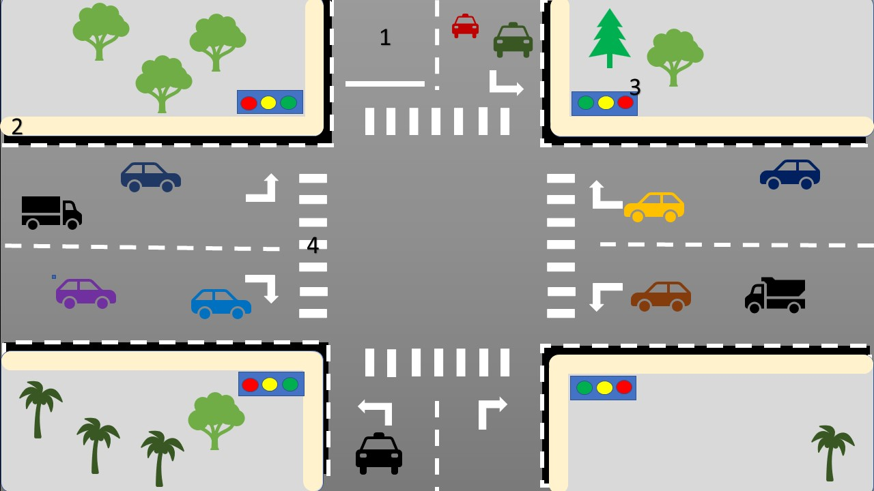

1. Road will be closed and be open for one way from 7AM to 9AM.
2. Footpath for Pedestrian crossing.
3. Traffic lights.
4. Cross Roads for Pedestrian.